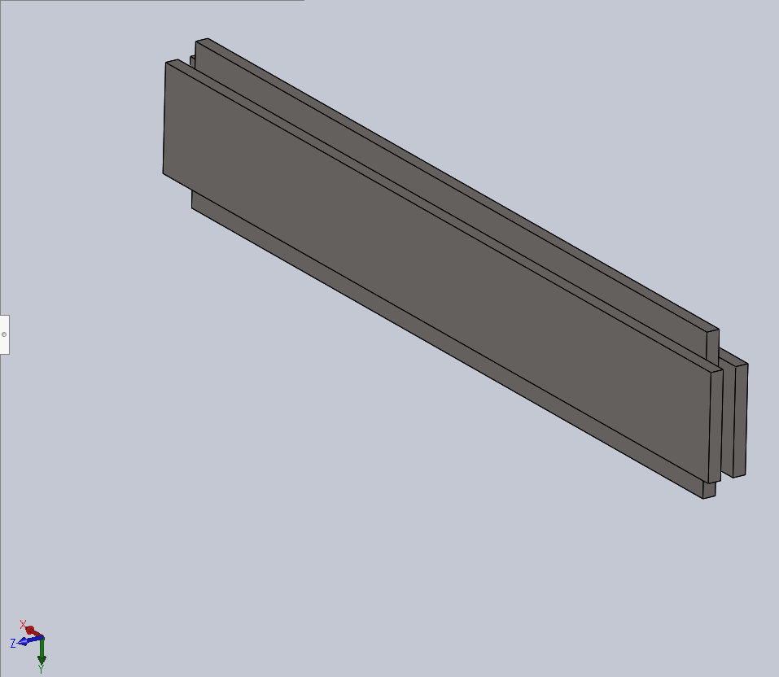

Figure 1 First model made of silicon

Figure 1 above shows the first model produced that is made of silicon. The structure is made up of two pieces of silicon material with a dimension of 320 $μ$ m $×$ 40 $μ$ m $×$ 5 $μ$ m (Length $×$ Width $×$ Height) sandwiching a piece of silicon material with a dimension of 300 $μ$ m $×$ 60 $μ$ m $×$ 5 $μ$ m ((Length $×$ Width $×$ Height). The fixture of the material is set to have fixed geometry on one side of the structure and rollers (or sliders) are applied on the other end of the structure. On the end where rollers are applied, there is also a force of 5N acting perpendicularly on the structure. 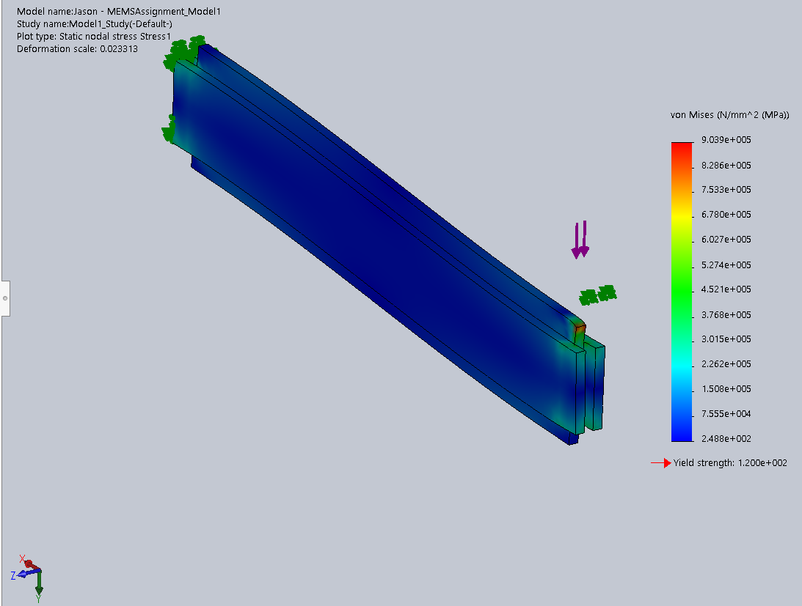

Figure 2 Model 1 that undergoes simulation of static study.

After running the simulation study, the results are shown in Figure 2 above. It can be observed that the whole structure has a von Mises stress of 248.8 MPa, which is also the minimum stress existed on the structure. The maximum stress is located at the tip of the structure near the roller end of the structure, which the stress reached 9.039 105 MPa, whereas the minimum stress existed is 248.8 MPa. It is also due to the reason that the existence of external load introduced to the system that causes the stress to be much higher on the loaded side. The yield strength calculated from the simulation for the structure is shown as 120 MPa. The simulation also shows that the model has a deformation scale of 0.023313. The simulation data is shown in Figure 3 below,

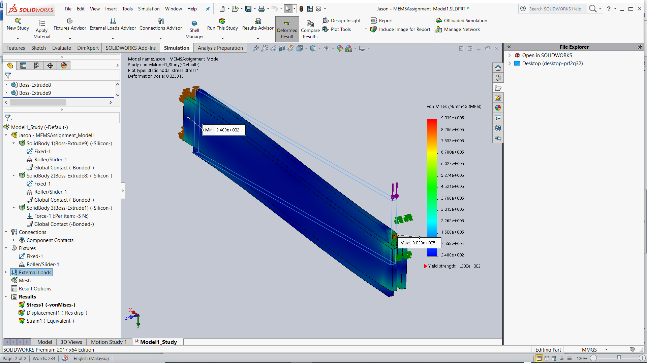

Figure 3 Simulation data for Model 1

Figure 4 below shows the second model produced that is made of the same material, which is silicon. The structure is made up of two pieces of silicon material with a dimension of 120 $μ$ m $×$ 5 $μ$ m $×$ 40 $μ$ m (Length $×$ Width $×$ Height). The fixture of the material is set to have fixed geometry on one side of the structure and rollers (or sliders) are applied on the other end of the structure. On the end where rollers are applied, there is also a force of 5N acting perpendicularly on the structure. Similarly, simulation is conducted again for the second model.

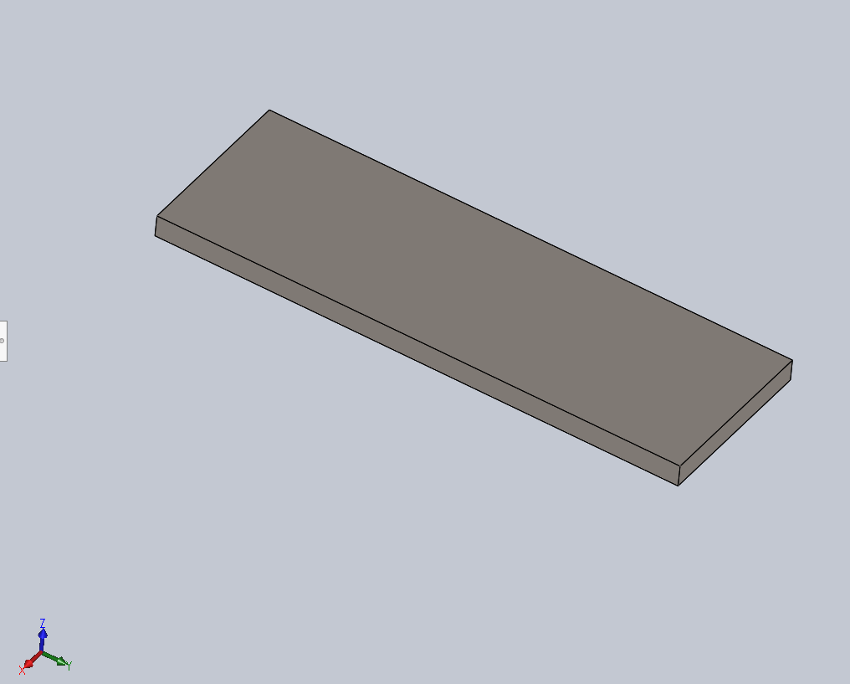

Figure 4 Second model made of silicon

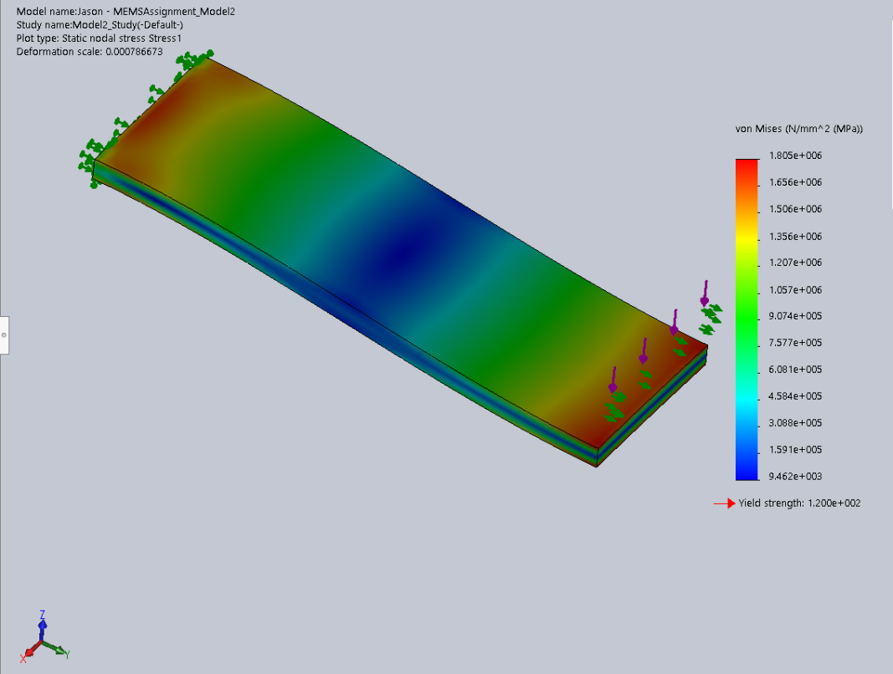

Figure 5 Model 2 that undergoes simulation of static study.

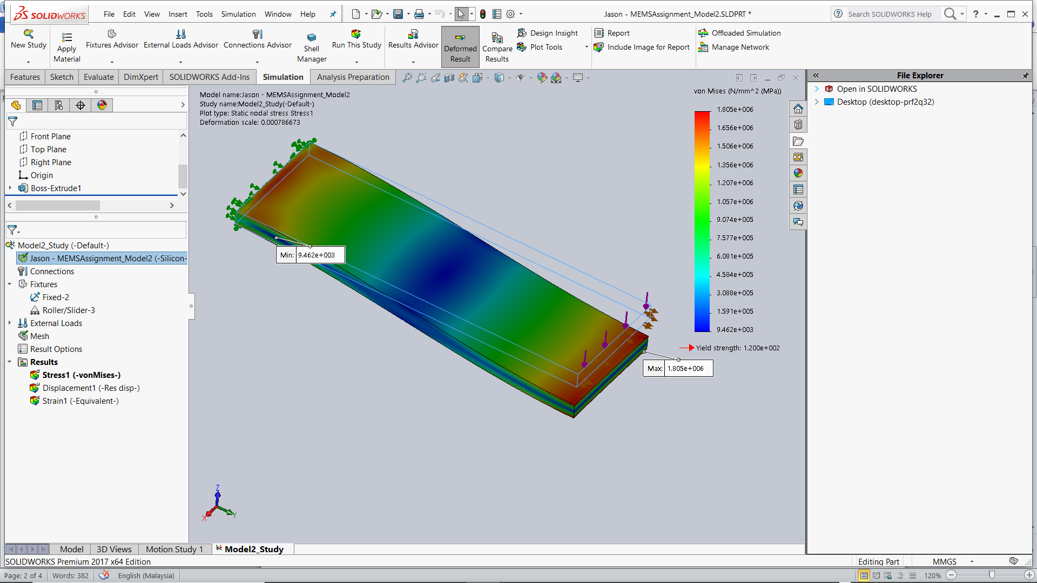

Figure 6 Simulation data for Model 2

From the information obtained from the simulation shown in Figure 6, it is found that the von Mises stress starts to raise significantly from the middle section to both sides of the material. Higher stress are detected to be found on the sides of the structure that is shown in the red region. The maximum stress existed on the structure is 1.805 106 MPa, while the minimum stress found is 9.462 103 MPa. The yield strength calculated from the simulation for the structure is still the same as Model 1, which is 120 MPa. The simulation also shows that the model has the same deformation scale of 0.023313.